Practical no. 22
Name :- Danish Altaf Solkar Enrolment no. :-24111590805
Class :- CO3K – B Subject :- DMS
Aim:- Implement PL/SQL program based on Exception Handling
(Pre-defined exceptions) application

Program :-
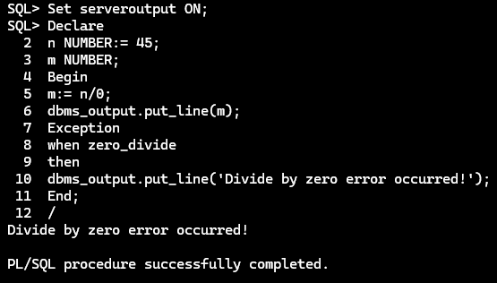

Program :-
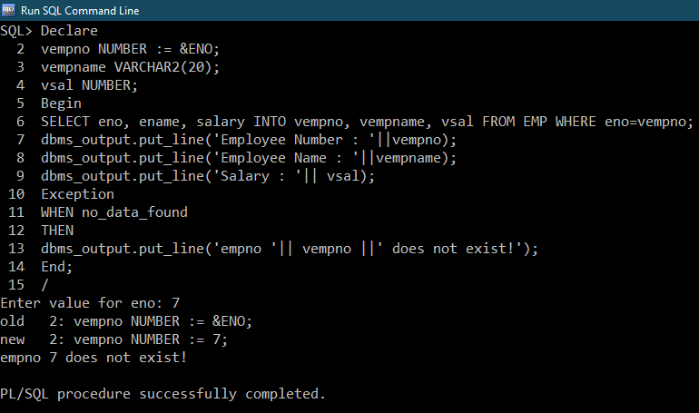
Program :-
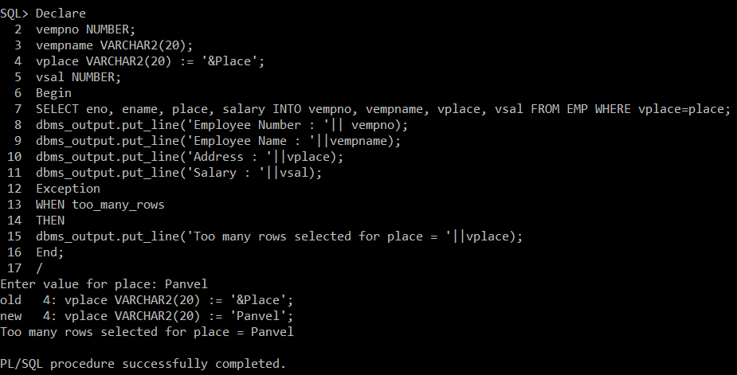

Program :-
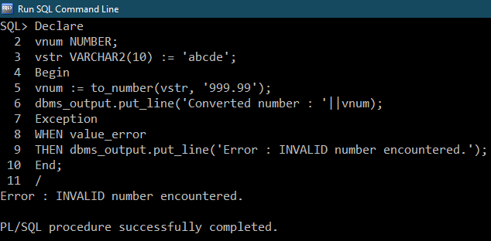

Program :-
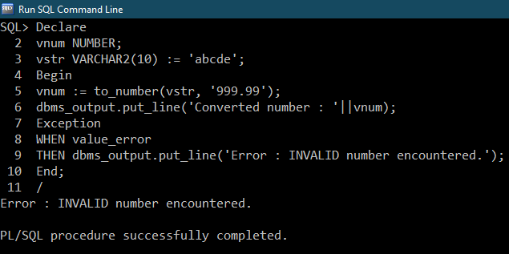

EXERCISE :-
